Anand B. Samant (DESIGN ENGINEER)  RESUME  9902641583_Gulam Hussain/ | 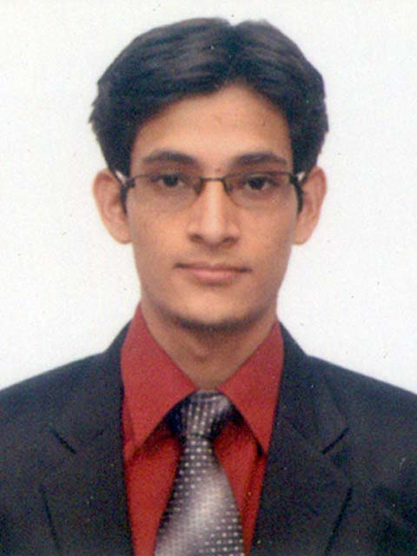
  Citizenship : Indian
  Date of birth : 8th December,1992
  Current City : Koparkhairane (Navi Mumbai)
  Contact
  Mob. : + 91-9987159405 / 7977605588
  E-mail : anandsamant08@gmail.com
Career Objective
To contribute to the organization’s growth by being a Team & Result oriented person. To devote my Technical skills for attaining the organizational goals and maximizing personal learning.

Professional Summary
Responsible and experienced Solar Power Engineer with an excellent record of individual and corporate customer satisfaction. Mindful of and knowledgeable about all local state and federal environmental rules and regulations. Adept at explaining complex technical engineering concepts clearly and accessibly to a wide variety of professional and non-professional audiences.

Academic Credentials
S.N. | Qualification | Institute | Year | Percentage
1 | B.E.- Mechanical Engineering  (Aggregate of Sem I to Sem VIII) | Bharti Vidyapeeth College of Engineering, Navi Mumbai  (UNIVERSITY OF MUMBAI) | 2011-2015 | 70 %
2 | Higher Secondary School Certificate Examination (12th) | Karmveer Bhaorao Patil College (MODERN COLLEGE), Vashi, Navi Mumbai  (MAHARASHTRA BOARD) | 2010-2011 | 81%
3 | Secondary School Certificate Examination (10th) | Maharishi Vidya Mandir, Pithoragarh, Uttrakhand.  (C.B.S.E.) | 2008-2009 | 81.83%

SOFTWARE PROFICIENCY:
- AutoCAD
- SketchUp
- PV SYST
- Aurora Solar
- CatiaV5
- Solidworks
- Creo/Pro-e
- Inventer 3D

Work Experience
1-  2- | Organization : Suntuity renewable energy LLP  Designation : Design Engineer  Duration : 1 year (October 2016 - present)  Field : Photovoltaic Solar Energy Generation  Work summary :  - Creating Solar Proposal (Lease and Ownership) & Cost Analysis.  - Preparation of Engineering Drawing with Electrical and Structural calculations.  - Calculation of wire sizing and breaker size in DC and AC side using NEC 2014 reference.  - Selection of Inverter, conduit size, solar module for maximum power generation.  - Shade calculation on Aurora and software and provide accurate shade analysis to customer.  - Correspondence with sales teams.  - Preparation of As-Built Drawings and Commissioning package.  - Origination & Review of Solar PV system already installed.  Skills :  - Wide knowledge of AHJ and Utility requirements for solar design.  - Strong ability to draft and interpret solar power design plans.  - High proficiency in AutoCAD and Microsoft Office Suite.  - Sound familiarity with solar power engineering industry safety rules and regulations.  - Superior ability to implement mechanical structural and electrical civil engineering designs.  - Outstanding oral and written communication skills with clients in USA.  Organization : V2Solution, Vashi , Navi Mumbai  Designation : Design Engineer  Duration : 1 Year and 4 months (June 2015 to September 2016)  Field : Photovoltaic Solar Energy Generation  Work summary :  - To design the roof-top Solar panel system using Auto CAD.  - Analyzing solar access & shade reports to gain maximum performance from the system.  - Analyzing point of connection & generating electrical line diagrams.  - Designing of entire solar energy system including PV module selection, inverter selection, system sizing, array layout designing w.r.t azimuth & tilt, tilt-racks, mounts & stringing.

Other Qualifications
- Participated in Workshop of Solarclan held in IIT-B
- Participated in Auto CAD competition in CADD center
- Participated in Workshop of Automobile Mechanics and I.C Engine hosted by IISC- Bangalore

Personality Attributes & Skills
- Ability to work for the best improvement of the company under pressurized conditions.
- Excellent analytical skills.
- Good communication skills .

Final Year Project
- Project title – Dual Refrigeration
- Aim – Refrigerator and Heating oven works side by side without spending
additional energy

Hobbies
- Playing Football
- Listening Music
- Watching T.V.
- Cycling

Extra Curricular Activities
- Participated in inter-college sports competition
- Participated in Paper Presentation competition
- Participated in Group Discussion competition held in college
- Participated in lathe machine operation competition
Personal Profile
Full Name  Father’s Name  Gender  Marital Status  Religion  Language known  Address | : Anand Bahadur Samant  : Bahadur Samant  : Male  : Single  : Hindu  : English, Hindi, Marathi  : Room No.-611, Sector-8, Koparkhairane, Navi Mumbai-400709

Declaration
I hereby declare that all the above information is true and best to my knowledge.
Reference- 9902641583-Gulam Hussain

Date : …………………………
Place : ……………………….. (Anand B. Samant)

